## **Workshop Assignment: Transforming Business Capability Models with Agentic AI**

### **🎯 Objective:**

Help Enterprise Architects (EAs) understand how to evolve from traditional AI automation to Agentic AI by embedding intelligent agents into Business Capability Models (BCMs) across enterprise architecture layers.

### **📘 Assignment Instructions:**

1. **Map a Traditional Capability** Choose a business capability from your domain (e.g., Supply Chain, Customer Engagement, Manufacturing Ops).  
    a. Describe how it currently operates with traditional automation.  
    b. Identify its limitations.
2. **Design the Agentic AI Transformation** Reimagine this capability using Agentic AI.  
    a. Define what decisions or tasks AI agents will take on.  
    b. Highlight cross-functional impacts.  
    c. Consider data, application, and technology requirements.
3. **Align with EA Layers** Break down how this transformation integrates into:  
   * Business Architecture
   * Data Architecture
   * Application Architecture
   * Technology Architecture
4. **Governance and Risk** a. Describe your approach to trust, transparency, and accountability for autonomous agents.  
    b. What TRiSM (Trust, Risk, Security Management) measures would you propose?
5. **Roadmap for Execution** a. Define the MVP (minimum viable pilot) for one AI-augmented business function.  
    b. Suggest phases for scale-up (e.g., 0-6 months, 6-12 months, 12+ months).

### **✅ Example Solution**

#### **1. Traditional Capability: Customer Service**

* **Today**: A chatbot handles FAQs. Complex queries escalate to human reps.
* **Limitations**: No personalization, no proactive resolution, poor escalation context.

#### **2. Agentic AI Transformation**

* **AI Agents Tasks**:  
  + Preemptively resolve issues based on behavior signals
  + Summarize case history and route to right team
  + Predict churn and offer retention plans
* **Cross-Functional Impact**:  
  + Syncs with sales, fulfillment, marketing
  + Reduced ticket volume and response time
* **Data Required**:  
  + Customer profiles, interaction history, product usage logs

#### **3. EA Layer Alignment**

* **Business**: Redefine service capability to include AI-led self-resolution
* **Data**: Real-time ingestion from CRM, web, and support channels
* **Application**: Integrate into Service Cloud, Marketing Cloud
* **Technology**: Deploy via Data Cloud, integrate vector DB for semantic search

#### **4. Governance**

* Create Responsible AI task force
* Define escalation thresholds for human handover
* Monitor agent performance, transparency logs, and decision audit trails

#### **5. Roadmap**

* **MVP**: AI agent that handles Tier-1 password resets + basic entitlement checks
* **0-6 months**: Integrate with knowledge base, build RAG system
* **6-12 months**: Deploy predictive routing and churn analysis
* **12+ months**: Multi-agent orchestration across support, sales, and CX

## **✅ Example 1: Supply Chain & Logistics**

### **Traditional Automation:**

* Automated procurement tools place orders when inventory drops below threshold.
* Tools rely on static rules and scheduled data syncs.

### **Limitations:**

* No dynamic risk adaptation (e.g., supplier delays, geopolitical disruptions).
* Doesn’t reroute logistics based on external variables (e.g., weather, customs).

### **Agentic AI Transformation:**

* **AI Tasks**:  
  + Detect global supply risks in real-time (e.g., using news/social feeds).
  + Re-prioritize supplier selections and reroute logistics paths dynamically.
  + Adjust lead times and notify impacted stakeholders proactively.
* **Cross-Functional Impact**:  
  + Real-time alignment across finance, procurement, and warehouse systems.
  + Proactive spend control and risk mitigation.
* **EA Layer Integration**:  
  + **Business**: Adaptive logistics orchestration
  + **Data**: External feeds (weather, port data), real-time inventory
  + **Application**: Integrated with ERP, TMS (transportation management system)
  + **Technology**: Uses streaming data platforms (Kafka), vector DB for vendor profiling

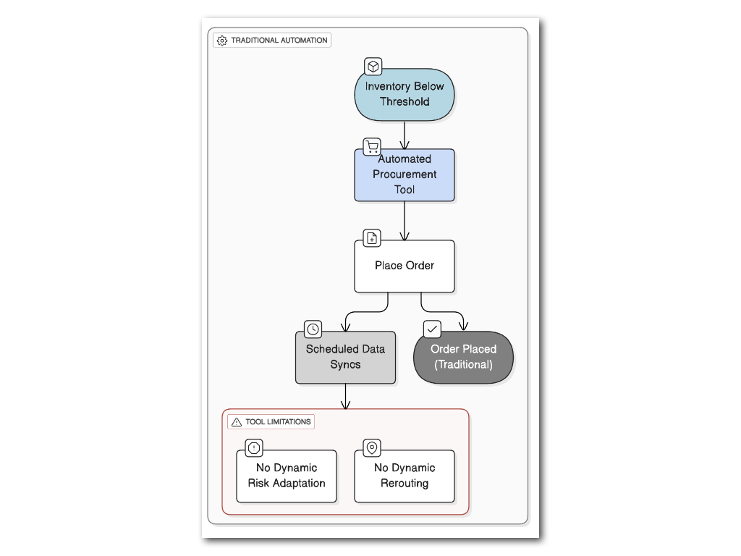

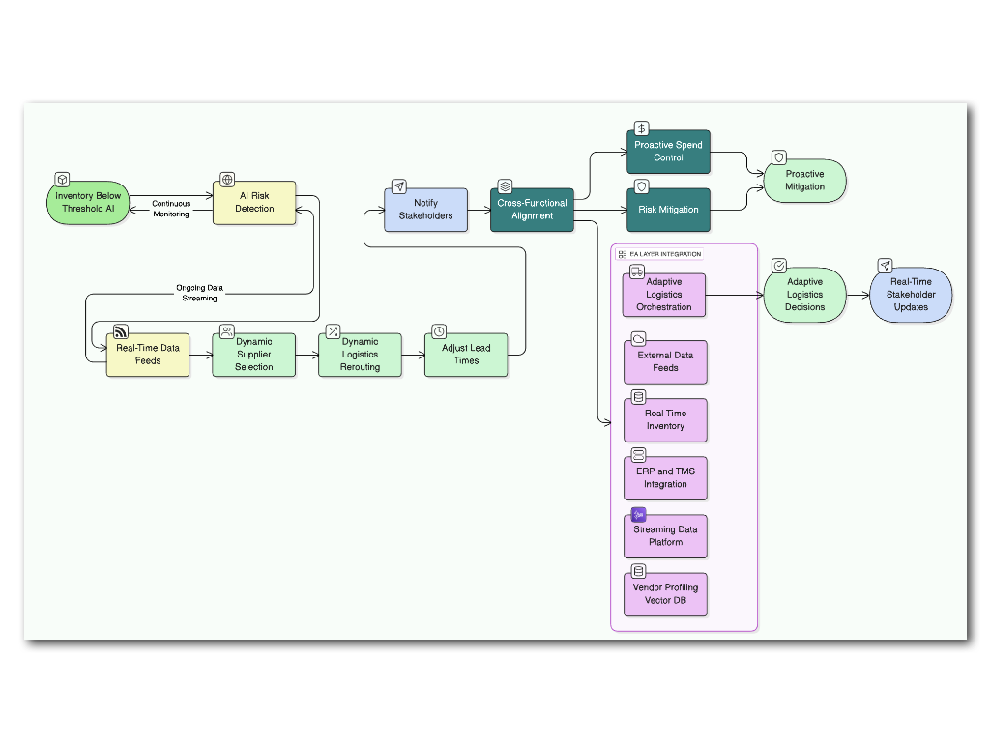

## **✅ Example 2: Manufacturing Operations**

### **Traditional Automation:**

* AI-powered defect detection systems using computer vision
* Scheduled maintenance based on usage thresholds

### **Limitations:**

* No feedback loop to alter production schedules
* Maintenance teams still rely on manual prioritization

### **Agentic AI Transformation:**

* **AI Tasks**:  
  + Predict defect trends and dynamically adjust machine usage
  + Reschedule production based on machine health and defect rates
  + Generate preventive workflows for parts most prone to failure
* **Cross-Functional Impact**:  
  + Aligns maintenance, production planning, and procurement teams
  + Reduces waste, downtime, and improves OEE (Overall Equipment Effectiveness)
* **EA Layer Integration**:  
  + **Business**: Continuous production optimization
  + **Data**: Real-time telemetry, past defect logs
  + **Application**: MES integration (Manufacturing Execution Systems)
  + **Technology**: Edge AI, IoT platforms, RAG-enabled dashboards

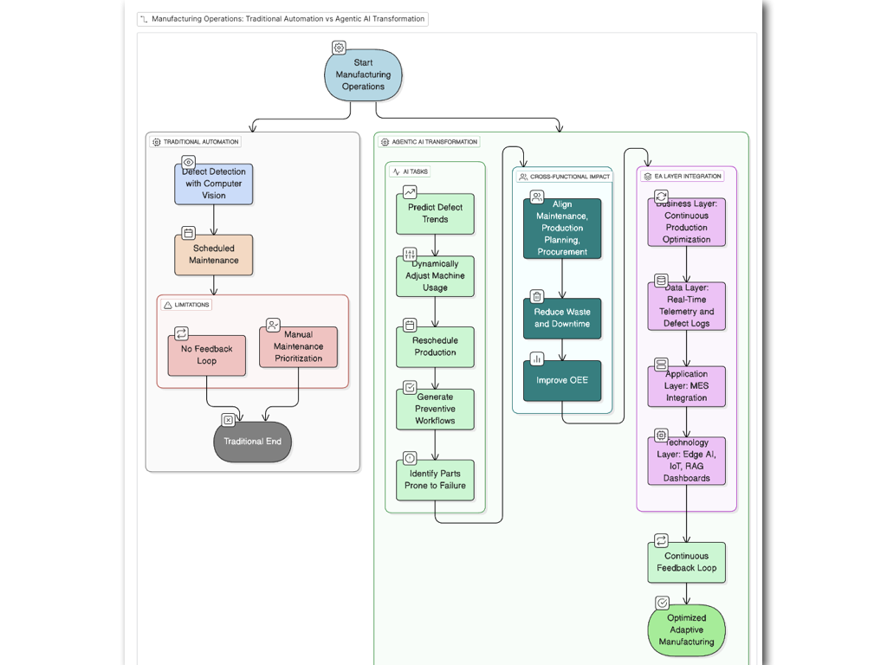

## **✅ Example 3: Sales & Customer Engagement**

### **Traditional Automation:**

* AI chatbots respond to customer questions
* Next-best-action tools suggest product offers

### **Limitations:**

* No personalization beyond surface-level CRM info
* No strategy adaptation based on churn risk signals

### **Agentic AI Transformation:**

* **AI Tasks**:  
  + Predict account health and churn probability
  + Personalize outreach timing and tone based on interaction history
  + Auto-configure campaigns based on buyer personas and LTV
* **Cross-Functional Impact**:  
  + Sales, marketing, customer success all get unified behavior insights
  + Intelligent segmentation improves conversion and retention
* **EA Layer Integration**:  
  + **Business**: Adaptive engagement models
  + **Data**: CRM + behavioral + product usage
  + **Application**: Sync with Marketing Cloud, Sales Cloud
  + **Technology**: Data Cloud, RAG for content retrieval and response generation

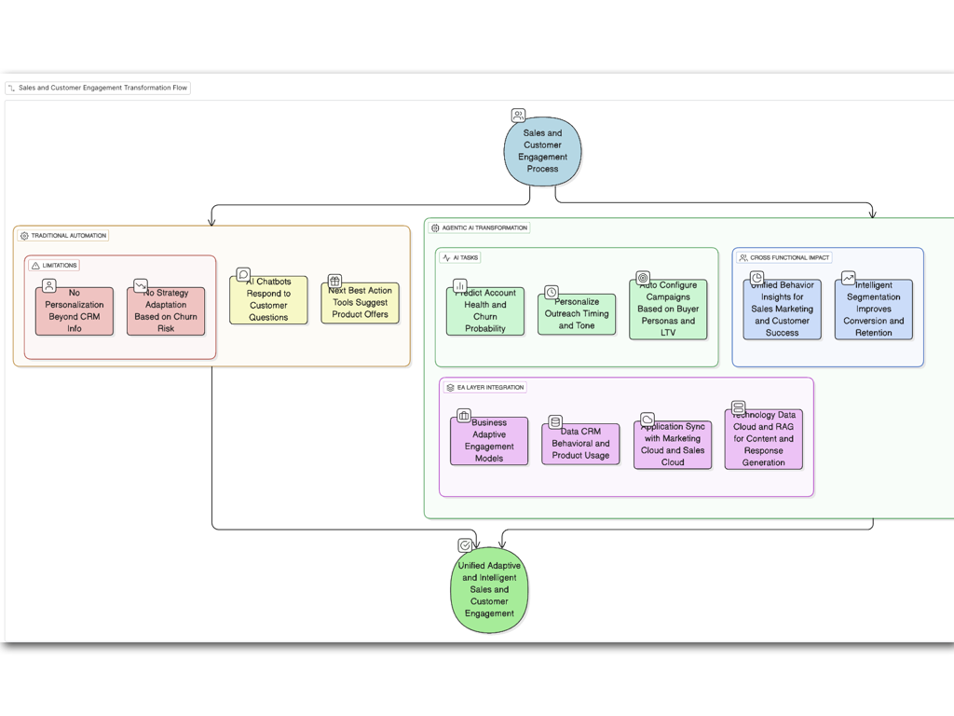

## **✅ Example 4: Customer Experience & Service**

### **Traditional Automation:**

* Automated case routing, claim processing bots
* Limited visibility into logistics or product lifecycle

### **Limitations:**

* Can’t account for delays or update customers proactively
* Poor synchronization between support, logistics, and product teams

### **Agentic AI Transformation:**

* **AI Tasks**:  
  + Update customers on real-time delivery delays
  + Offer dynamic warranty extensions if product shipment is delayed
  + Predict dissatisfaction from tone/emotion in support logs and trigger interventions
* **Cross-Functional Impact**:  
  + Harmonizes support, logistics, and product updates
  + Enhances CX metrics like CSAT, NPS, and first-contact resolution
* **EA Layer Integration**:  
  + **Business**: Predictive service orchestration
  + **Data**: Shipping, service logs, sentiment analysis
  + **Application**: Service Cloud, Knowledge Base, Logistics APIs
  + **Technology**: NLP, prompt-chaining, GenAI for empathetic response generation

